I need a filter for certain traits and prices.There are 3 types of gene:

**Dominant (D):** 37.5% chance to pass this gene to offspring.

**Recessive (R1):** 9.375% chance to pass this gene to offspring.

**Minor Recessive (R2):** 3.125% chance to pass this gene to offspring.

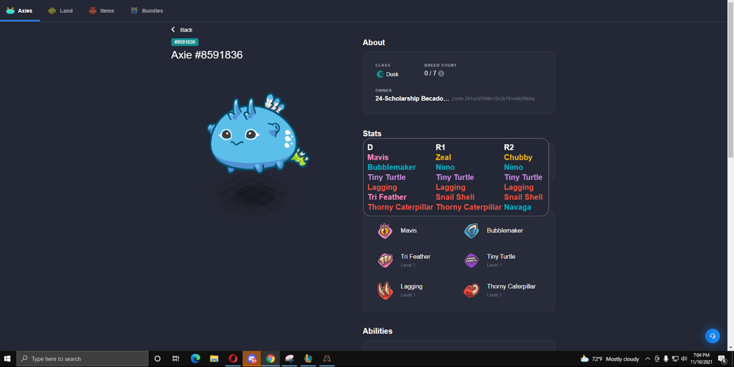

Install this extension: <https://chrome.google.com/webstore/detail/freaks-axie-extension/copjnifcecdedocejpaapepagaodgpbh?hl=en>

And when you move your mouse over “Stats” it will show D (Dominant), R1 (Recessive) and R2 (Minor Recessive)

And then for the bot, allow me to put their D,R1 and R2 gene as an option, alerts when price falls under a certain number(price) that I input.

Also for filters, I want to filter out how many times that axie has been bred. Their health, speed, skill and morale. Also filter the pureness too, for example if I want the pureness to be over 6/6 meaning all the Dominance genes are all, here is an example for aqua 6/6 pureness.

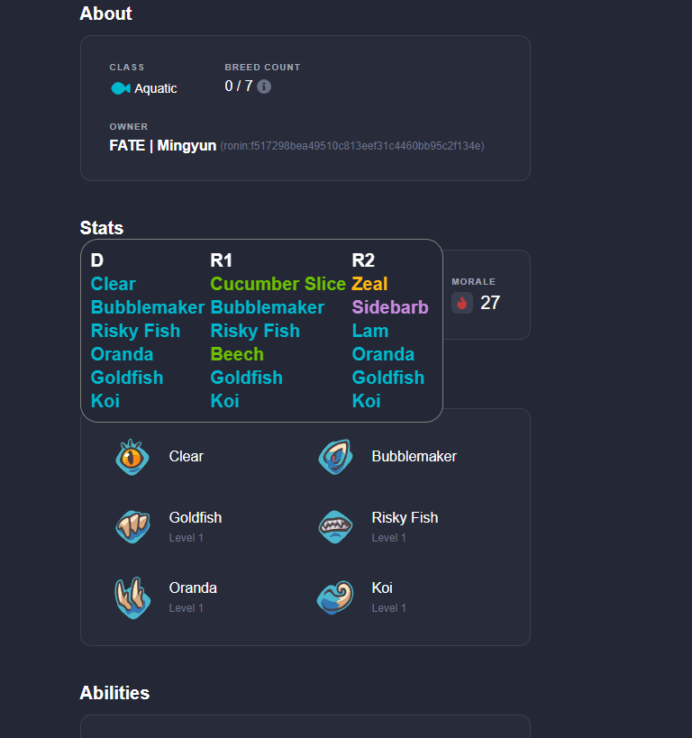

As you can see the D gene is all blue.

okayyou home yet?this is the api for getting D,R1,R2

[https://axieinfinity.com/graphql-server-v2/graphql](https://www.freelancer.com/users/l.php?url=https://axieinfinity.com/graphql-server-v2/graphql&sig=0a1e030c16a8c479b217f40a2d6be8e744139ae74192c1c137bf367972db08f1" \t "https://www.freelancer.com/messages/thread/_blank)

[https://discord.gg/axie](https://www.freelancer.com/users/l.php?url=https://discord.gg/axie&sig=19bc74714125f3c40a57d625b59f7c360eb77bcf0aad662ca0900a4bf6b1c92f" \t "https://www.freelancer.com/messages/thread/_blank)

you can join this discord when you get homethere is a section called #tools-api-etcyou should be able to find any api you wantedlist of axie apiP

[https://axie-graphql.web.app/](https://www.freelancer.com/users/l.php?url=https://axie-graphql.web.app/&sig=3be59857f24e58025738aece1ff05a6869bb4144f8cb4bf1c4af813d21d52656" \t "https://www.freelancer.com/messages/thread/_blank)